Medical Surveillance Module

Main Transaction
Medical Surveillance Transaction

Table of Contents

Requirements Analysis
Systems Characteristics
Integration with Other Modules
User Pre-Requisites
Getting Started
Setups (None as yet)
Transactions
- Medical Surveillance Transaction: Recording Employee’s Medical Info …………………………..
Reports
- Medical Surveillance …………………………………………………………………………………………………
Utility Tools (None as yet)
Requirements Analysis
Systems Characteristics
Integration with Other Modules

Medical Surveillance Module is linked with the following FCL modules:

MSM

HR
Dependency Diagram
- Human Resource -HR

Relationship with HR Module

- Medical Surveillance Module uses Employee Master file from HR Module to record medical information of an employee

User Pre-Requisites

Getting Started

The FCL Medical Surveillance Module consists of a single transaction as well as a report.
In the subsequent pages, recording an employee’s medical information is illustrated with the help of screen-shots.
Medical Surveillance Transaction _______________________________________________________________________________
Use case: Recording an Employee’s Medical Details

Description
This form helps a physician enter all kinds of medical information about an FCL employee with the following data entry:
General Tab
- Date of Surveillance
- Employee Info (to be fetched from HR):
- Code & Name - Department - Birth Date - Joining Date - Photo
- Medical History
- Chronic Disease (if any)
- Asthma - HTN - IHD - DM - Any Other
- Personal Habits
- Smoking - Substance Abuse - Exercise
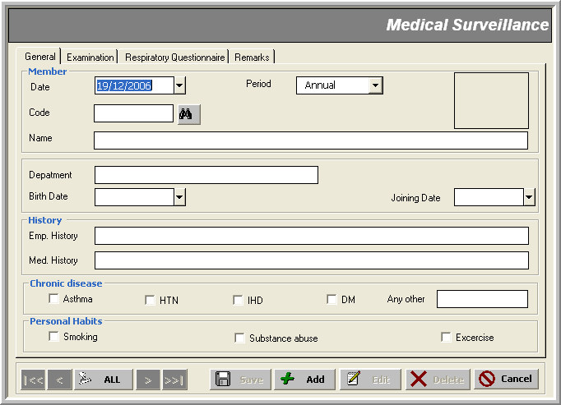
* Employee Code

Examination Tab
- Pulmonary Function Tests / Spirometry
- Laboratory Investigations:
- Chest X-Ray
- Others
- General Physical & Systemic Examination (if any)
- Build - Weight - Height - BMI - BP - Pulse
- GIT - CVS - CNS - Respiratory - Skin
- Remarks / Advice
- Remarks - Next Checkup Date

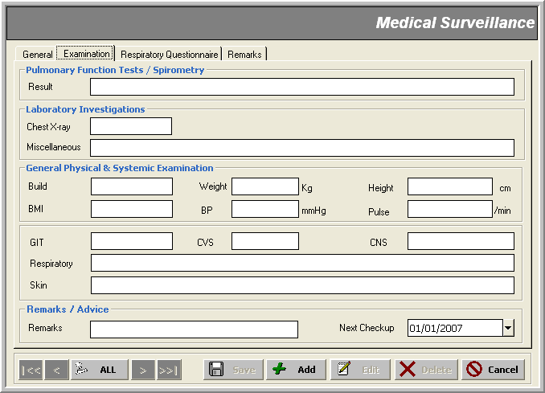

Note that:
- Respiratory Questionnaire tab contains a number of questions about the employee’s respiratory system:
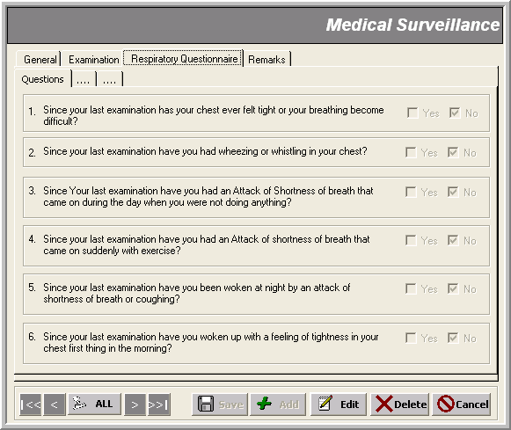
- Remarks tab is there for the doctor to make any comments on the patient’s checkup; remarks on the answers given in the previous ‘Respiratory Questionnaire’ could be saved away along with the question number
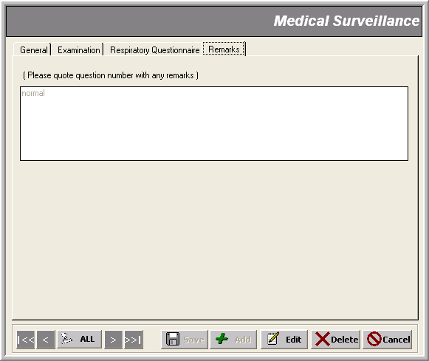

Reports
_______________________________________________________________________________

